Volunteers in Victoria
Trends, challenges and opportunities

To receive this publication in an accessible format email Volunteers Council <volunteers.council@dhhs.vic.gov.au>
Authorised and published by the Victorian Government, 1 Treasury Place.
© State of Victoria, Ministerial Council for Volunteers, June 2017.
Except where otherwise indicated, the images in this publication show models and illustrative settings only, and do not necessarily depict actual services, facilities or recipients of services. This publication may contain images of deceased Aboriginal and Torres Strait Islander peoples.
Where the term ‘Aboriginal’ is used it refers to both Aboriginal and Torres Strait Islander people. Indigenous is retained when it is part of the title of a report, program or quotation.
ISBN 978-0-7311-7258-0 (online/MS word)
Available at Ministerial Council for Volunteers<http://www.providers.dhhs.vic.gov.au/ministerial-council-volunteers>

Contents
Introduction 5
About this report 5
A snapshot of volunteering 6
Defining volunteering 8
Formal volunteering 8
Informal volunteering 8
Community volunteering 8
Corporate volunteering 9
The volunteer sector in Victoria 10
Ministerial Council for Volunteers 10
Volunteering Victoria 10
Local government 10
Volunteer support organisations 11
Volunteering trends in Victoria 12
Rates of participation present a challenge 12
Trends by age 13
Trends by gender 14
Type of organisation and role 14
Trends by region 16
Volunteering in cultural and linguistically diverse communities 20
Volunteering among seniors 20
Volunteering in the lesbian, gay, bisexual, transgender and intersex community 22
Sectors supported by volunteers 23
Sport and recreation 23
Education and training 24
Welfare and community 25
Religious 26
Emergency services 27
Health services 28
Arts, culture, heritage 30
Environment and conservation 30
Benefits of volunteering for Victoria 32
A stronger social fabric 32
Cultural benefits 32
Environmental benefits 34
Economic benefits 34
Benefits for individuals 35
Opportunities 36
Volunteer expectations are changing 36
The role of leaders 36
Intergenerational influence and childhood participation 37
Improving rates of volunteering among disadvantaged communities 38
Online resources for volunteers 40
Conclusion 41
References 42

Introduction
Volunteers are a vital part of Victoria’s social, economic, cultural and environmental fabric, and volunteering delivers immense value to Victoria, for communities, places and individuals.
This includes an economic contribution worth around $23 billion to Victoria in 2011, and which is set to hit $42 billion by 2021 (DPCD 2012).
In addition to the direct economic benefits provided by a volunteer workforce of 1,511,500 Victorians, volunteering has many direct and indirect benefits for the strength and resilience of Victorian communities.
Volunteers undertake important and valuable work that improves social cohesion, and makes our communities stronger, safer and more liveable.
The Victorian Government recognises the vital contributions of volunteers through annual celebrations, including the Premier’s Volunteer Champions Awards and Minister for Health Volunteer Awards.
Some of the social benefits of volunteering include:
- boosting health and wellbeing – volunteers improve others’ wellbeing, and they are happier themselves
- creating pathways to employment – volunteering connects people to labour markets
- delivering services – volunteers do things that the paid workforce cannot
  - building resilient communities – volunteers keep people safe and help communities recover from disaster.
But the nature and extent of volunteering is changing in Victoria, and unless we take action to protect and enhance volunteering, we risk losing the value of these benefits.
Across Australia, reported rates of volunteering fell 10 per cent over the eight years from 2006 to 2014 (ABS 2015). In Victoria, different datasets tell different stories, but rates of volunteering have remained static – and are low among some disadvantaged communities.
Demographic changes brought about by increasing cultural diversity and a growing and ageing population mean we need to find creative solutions to ensure the future of Victoria’s volunteer sector.
There is an opportunity now to strengthen and grow volunteering to stand us in good stead for the future, and with a strategic, long-term and place-based approach, we can drive a strong and vibrant culture of volunteering in Victoria.

About this report
This report has been produced by the Ministerial Council for Volunteers (‘the Council’) to provide contemporary Victorian evidence on the current state of the economic and social value of volunteering.
Findings from this report will highlight key trends, challenges and opportunities for volunteering, and inform the development of strategic priorities to strengthen and support the volunteer sector in Victoria.

A snapshot of volunteering
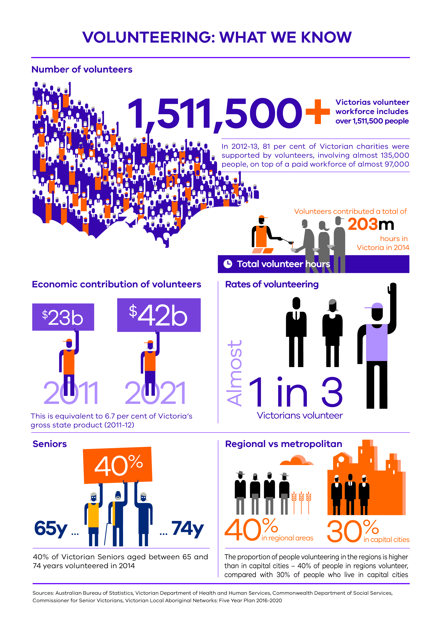
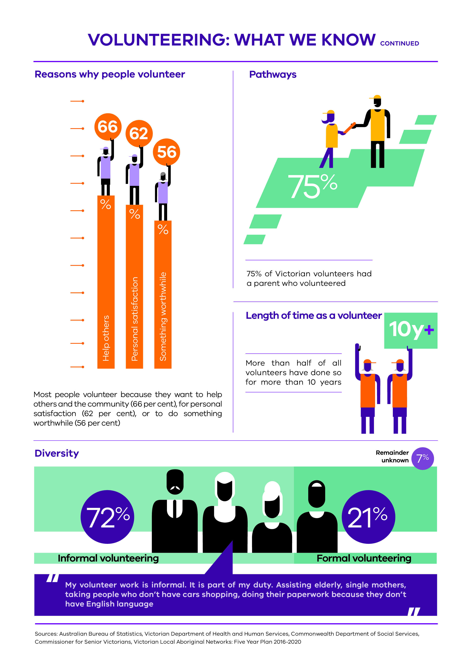

Defining volunteering
The way we define volunteering is important to ensure that we can measure all of its benefits.
Traditional definitions of volunteering tend to emphasise formal volunteering roles within organisations, but there is a growing recognition by researchers seeking to measure its effects that volunteering is far more diverse than this.
Volunteering Australia’s definition of volunteering is ‘time willingly given for the common good and without financial gain’ (Volunteering Australia, 2016). This broad definition encompasses the spectrum of volunteering activities including formal volunteering, informal volunteering, community volunteering and corporate volunteering.
For the first time, the national definition also includes activism and employee volunteering through an organisation.
In its General Social Survey, the Australian Bureau of Statistics (ABS) focuses on formal volunteering. The ABS defines a volunteer as ‘someone who, in the previous 12 months, willingly gave unpaid help in the form of time, service or skills, through an organisation or group’ (ABS, 2015).

Formal volunteering
The definitions outlined above distinguish between formal volunteering and informal volunteering.
Formal volunteering activities are those undertaken through public, private, non-government and community organisations.
In formal roles, volunteers may have a position description for their work, and might work a set number of hours per week on a roster. Others may also work on longer cycles, for example monthly, and may not have position descriptions but may have a list of duties instead.

Informal volunteering
Informal volunteering takes place outside of an organisation, and may include providing support for another person who does not live in the same house, such as a relative or friend.
Many people who undertake informal volunteering do not self-identify as volunteers.

Community volunteering
As an extension to informal volunteering, people in some communities see the informal voluntary work they do for the community as just part of what it means to belong to that community.
The Cultural and Indigenous Research Centre Australia (CIRCA, 2016) finds, for example, that people from culturally and linguistically diverse and Aboriginal backgrounds do not necessarily consider their contribution to the community as volunteering.
Quote from an Iraqi Mandaean woman:
‘In Arabic there is a saying: if you give in your right hand, you receive in your left hand’.
Source: CIRCA, 2016, p. 25.
Rather than undertaking ‘informal’ or ‘formal’ volunteering, Aboriginal people in the CIRCA study were more likely to be engaged in ‘community volunteering’ – which is more fluid, flexible, local and responsive to community needs (CIRCA, 2016).
Quote from an Aboriginal woman:
‘It’s just something we do, we don’t recognise it as volunteering, it’s our obligation, we pitch in, it comes natural to Aboriginal people’.
Source: CIRCA, 2016, p. 15.

Corporate volunteering
For the first time, Volunteering Australia’s definition of volunteering now includes corporate volunteering. This recognises the fact that entities donate employee time, which is a valuable contribution to the volunteer sector.

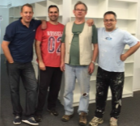
Volunteer profile: ANZ volunteers refurbish Epilepsy Foundation op shops:
Nine ANZ volunteers completed two major shop refurbishments within extremely tight deadlines.
They finished each shop in just two days, and gave a third shop a remarkable makeover in a single day.
For the volunteers, the outcome of the project offered bonding experiences and impressive, tangible results in a short turnaround period to support the Epilepsy Foundation.
Source: Premier’s Volunteer Champions Awards 2016

The volunteer sector in Victoria
Volunteer-involving organisations are extremely diverse, ranging from local councils and state government departments to grassroots collectives, community groups such as Landcare and local sports clubs, and large entities that deliver disability, health and aged care services.
They may be small, unincorporated groups or large national organisations and charities. For-profit entities also contribute in some parts of the sector.
State and federal governments, along with philanthropy and business, play a role in funding and supporting volunteer programs and services.
Similarly, many different groups and organisations provide volunteering support and capacity building.
The groups below make an important contribution to the volunteering sector in Victoria.

Ministerial Council for Volunteers
The Ministerial Council for Volunteers provides independent advice to government through the Minister for Families and Children.
Its work informs a whole-of-sector approach to supporting and strengthening the sector.
It has four key areas of focus:
- leadership
- technology
- valuing and positioning
  - sector collaboration.
In 2017, the Council will provide the government with its high-level recommendations for supporting volunteering in Victoria.

Volunteering Victoria
Volunteering Victoria is the peak volunteering body in Victoria.
It is a member-based organisation with over 350 not-for-profit, corporate, local government and individual members.
Volunteering Victoria focuses on advocacy, developing the sector and promoting volunteering.
It aims to develop a ‘collaborative, sustainable, thriving volunteering community and movement in Victoria’ (Volunteering Victoria, 2016a).
Its reach through newsletters, website and social media platforms is in excess of 600,000 people.

Local government
Thousands of volunteers support the delivery of local council programs and services, which include food delivery, aged care services, homework and home visits, walking buses and so on.
Most Victorian local councils have specific volunteer programs and designated staff involved in recruitment, training and supporting volunteers in their local areas.
They also run yearly volunteer awards to recognise volunteers.

Volunteer support organisations
Volunteer support organisations provide information about volunteering to the general public, and suggest volunteer positions that suit the needs of those interested in volunteering.
They also provide support and training to volunteer-involving organisations, and many also run community services using their own volunteers.
Volunteering Victoria (2016b) lists 26 organisations that are either volunteer support organisations or resource centres.
These organisations, also referred to as volunteer support services, are mostly not-for-profit, community or private organisations that support volunteers and volunteer organisations.
They can also be part of local government, such as the Boroondara Volunteer Resource Centre, Volunteering Warrnambool and others.

Volunteering trends in Victoria
Understanding demographic trends in volunteering can help us support volunteers and the organisations that depend on them.

Rates of participation present a challenge
Organisations that depend on volunteers face a challenge in attracting new volunteers, and in ensuring that rates of participation are adequate to provide a stable volunteer workforce.
According to the ABS (2015), Australia-wide rates of volunteering dropped from 42 per cent of the population aged over 15 years in 2006, to 32 per cent in 2014.
Figure 1: Rates of volunteering for Australia in 2006, 2010 and 2014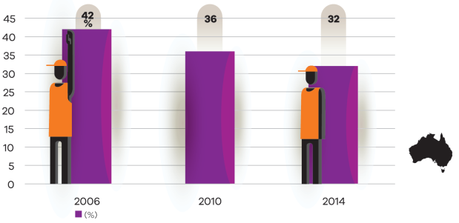
Source: Australian Bureau of Statistics, General social survey 2014, Voluntary Work 2006, 2010
While the ABS data for 2014 also shows the same trend occurring for Victoria, data from the Victorian Population Health Survey 2014 (DHHS, 2017) provides a more nuanced view.
This Victoria-only survey covers a much larger cohort of over 33,000 people, and shows a static level of volunteering in Victoria over the years from 2005 to 2014.
However, the survey also shows that in Victoria, there are lower self-reported rates of volunteering among particular communities – most notably people who speak languages other than English (see Figures 8 and 9).
This is of concern, as these culturally and linguistically diverse communities stand to gain from the benefits of volunteering in terms of social cohesion and health and wellbeing benefits, especially where they occur in areas of high population growth.
In rural and regional Victoria, where the majority of Country Fire Authority volunteers are located, the rate of volunteering for emergency services organisations (6 per cent) is higher than the national average of 2 per cent (Regional Development Australia, 2014).
However, the 2014 Regional Wellbeing Survey also notes concerns ‘that a high rate of volunteering may be difficult to sustain into the future, particularly in many rural communities that have a rapidly ageing population’ (Regional Development Australia, 2014).

Trends by age
Rates of volunteering are different at different life stages, as study, work and family commitments change across the course of a person’s life.
The youngest and oldest Victorians have the lowest rates of participation in volunteering, and there is scope to target the two youngest cohorts of 18–24 and 25–34 years to improve rates of volunteering.
People aged between 35–54 have the highest rates of volunteering. For much of the population, these years are characterised by raising children and involvement with school and community life.
This increase in volunteering at the age of 35 may also reflect Victoria’s relatively high average age for women giving birth, which was 31 years old in 2012 (Australian Institute of Health and Welfare, 2014).
Volunteering then drops off in the 55–64-year age group, as children leave home and people spend more time caring for ageing parents and preparing for retirement.
Rates of volunteering increase in the post-retirement years of 65–74 and then decrease moderately to the age of 84, before falling off sharply once people reach the age of 85 years.
Figure 2: Proportion of Victorians over 18 years who volunteered, by age, 2014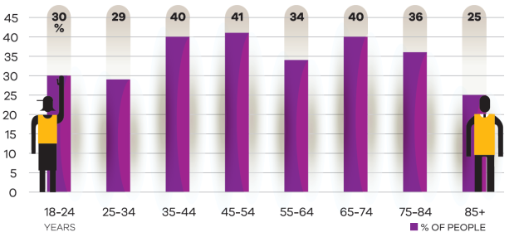
Source: Victorian Population Health Survey 2014 (DHHS, 2017)

Trends by gender
Overall, Australian women volunteer in slightly higher numbers than men (33 per cent versus 32 per cent) (ABS, 2015).
In 2014, Victorian women volunteered at a rate of 37 per cent compared with 34 per cent of Victorian men (DHHS, 2017).
In the two younger cohorts (18–24 and 25–34), women tend to volunteer at significantly higher rates than men.
Volunteer participation by women drops off between the ages 55–64, and women volunteer at lower rates than men later in life (65–85).
This shows that there are opportunities to encourage more younger men and older women to volunteer.
Figure 3: Proportion of male and female Victorians who volunteer, 2014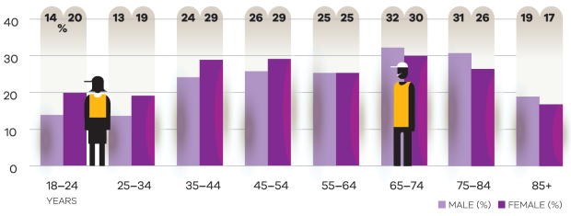
Source: Victorian Population Health Survey 2014 (DHHS, 2017)

Type of organisation and role
The ABS (2015) data in Figure 4 looks at the types of organisations where Victorians volunteer.
Sport and recreation organisations attract the highest proportion of volunteers (32 per cent), followed by education and training (25 per cent), welfare and community (21 per cent), religious (19 per cent) and health organisations (11 per cent).
The most common voluntary activities in Victoria are fundraising (22 per cent), teaching (15 per cent), administration (14 per cent), and coaching, refereeing and judging (14 per cent).
Figure 5 shows the breakdown of these activities in greater detail.
Data from the ABS (2015) also shows that 42 per cent of volunteers in Victoria volunteer for two or more organisations.
This trend could imply that if we encourage and support people to start volunteering, they are likely to continue, and indeed go on to have multiple volunteer roles.

The large ‘other’ category in Figures 4 and 5 is due to the fact that the ABS does not provide proportions of Victorians in organisations and roles that attract smaller numbers of volunteers overall.

Figure 4: Types of organisations where Victorian volunteers contributed, 2014
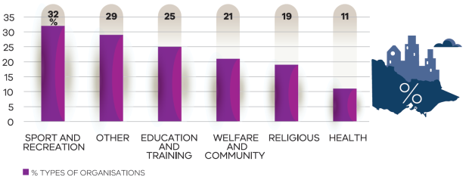
Source: General social survey 2014 (ABS, 2015)
The ‘other’ category includes: arts and heritage; business, professional and union; parenting, children and youth; emergency services; environment and animal welfare; international aid and development; law, justice and political; other recreation and interest; ethnic and ethnic-Australian groups; and other organisations.
Figure 5: Most common voluntary activities in Victoria, 2014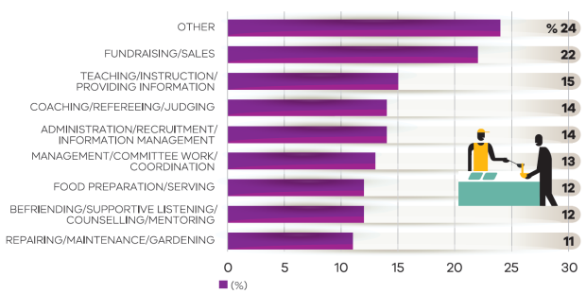
Source: General social survey 2014 (ABS, 2015)
The ‘other’ category in Figure 5 includes: performing and media production; transporting people or goods; personal care and assistance; lobbying, advocacy or policy research; search and rescue, first aid, fire-fighting or community safety; environmental protection; and other activities.

Trends by region
People living in rural and regional Victoria are more likely to be involved in their communities than people in cities and urban areas.
People and communities: the 2014 regional wellbeing survey (Schirmer et al., 2015) found that 54 per cent of people in rural and regional Victoria were currently involved in volunteering, and a further 29 per cent had previously volunteered.
This report also shows that in regional Victoria, the sport and recreation (15 per cent) and church and spiritual (10 per cent) sectors had the highest rates of weekly volunteering.
This is supported by the 2014 Victorian Population Health Survey data, which shows that 45 per cent of people in rural areas volunteer, compared with just 33 per cent of people in major cities (DHHS, 2017).
ABS data (2015) shows slightly lower rates of volunteering in both regional and metropolitan areas - 40 per cent in regional, and 30 per cent in metropolitan areas. Both data sets indicate a similar pattern.
Figure 6 shows these differences between regional and metropolitan rates of volunteering.
Figure 6: Rate of volunteering in adults in regional and metropolitan areas in Victoria, 2014
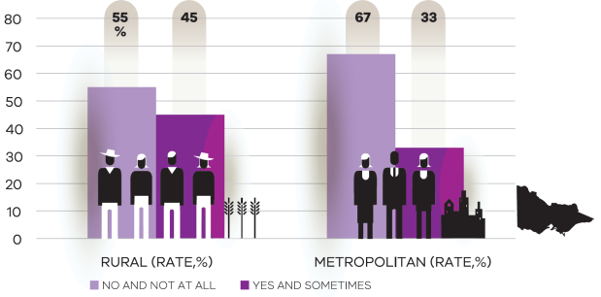
Source: Victorian Population Health Survey 2014 (DHHS, 2017)

Figure 7 shows that local government areas in rural and regional Victoria have higher rates of volunteering than those in metropolitan areas.
Figure 7: Rates of volunteering in adults by local government area, 2014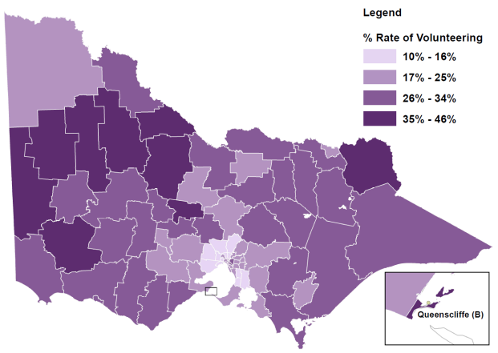
Source: Victorian Population Health Survey 2014 (DHHS, 2017)

Figure 8 shows that the ten Local Government Areas (LGAs) in Victoria with the highest reported rates of volunteering are in the rural areas. These LGAs have high levels of disadvantage and low percentages of people who speak a language other than English (LOTE).
Figure 8: Local government areas in rural and regional Victoria, by rate of volunteering and adult non-English speaking population, 2014
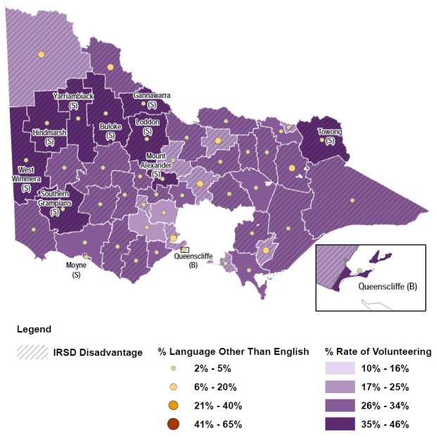
Source: Victorian Population Health Survey 2014 (DHHS, 2017), Australian Bureau of Statistics, Census 2011

Figure 9 shows that the ten LGAs in Victoria with the lowest reported rates of volunteering are in metropolitan areas, mostly with high levels of disadvantage and high percentages of LOTE speakers.
Figure 9: Local government areas in metropolitan Melbourne, by rate of volunteering and adult non-English speaking population, 2014
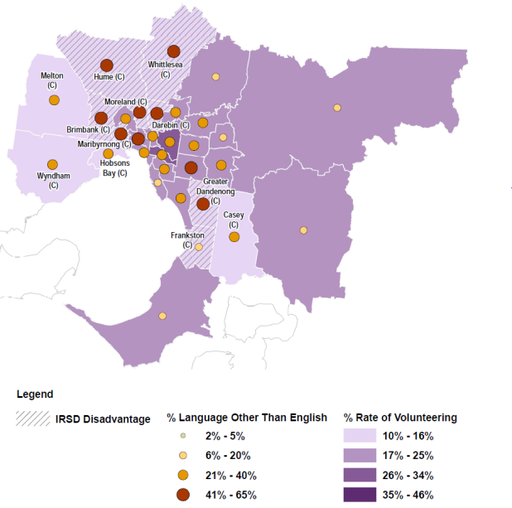
Source: Victorian Population Health Survey 2014 (DHHS, 2017), Australian Bureau of Statistics, Census 2011

Figures 8 and 9 indicate that, in Victoria, the percentage of LOTE speakers is a better predictor of the reported rates of volunteering than level of disadvantage.

Volunteering in cultural and linguistically diverse communities
ABS data (2015) shows that the rate of people aged 15 years and over engaged in formal volunteering was 32 per cent. For culturally and linguistically diverse (CALD) communities, the rate was 23 per cent.
Figures 8 and 9, which use Victorian Department of Health and Human Services data as well as ABS Census data, also show that lower reported rates of formal volunteering are associated with higher proportions of people from CALD backgrounds.
However, it is important to note that people from CALD backgrounds are more likely to be engaged in informal volunteering, or may not consider their contribution as volunteering at all.
CIRCA (2016) cites Volunteering Australia research from 2007, which finds that while only 21 per cent of CALD volunteers were engaged in volunteering through a mainstream organisation, 72 per cent were involved in informal volunteering, with 56 per cent involved in both their own community and the broader community, and 39 per cent working exclusively in their own community.
This demonstrates the importance of informal volunteering in CALD communities, and suggests that the Australian Bureau of Statistics’ census instrument could be revised to capture other forms of volunteering.

Volunteering among seniors
Figure 2 shows the high rates of volunteering in the 65–74-years and 75–84-years cohorts. The predicted growth of the seniors population in Victoria highlights the potential for increased volunteering, along with the benefits this brings to individuals and the community.
The Commissioner for Senior Victorians emphasises that the ageing population is a ‘good news story’ for volunteering, given the contribution seniors make to their communities.
The 2011 ABS Census shows that 25.6 per cent of the population (nearly 1.4 million Victorians at the time) were aged 55 and over. Today about one in five Victorians is aged over 60, and in just 15 years, by 2031, this will be about one in four. In raw numbers, this means that in about 15 years we will see growth in Victoria from about 1.8 million people aged over 60, to about 1.9 million.
The Commissioner for Senior Victorians reports that the growth rate of the population cohort aged 60 years and over is almost double that of the overall population growth, and argues that we need to focus on the opportunities and social impacts of these demographic changes, and offset the risks associated with increased social isolation among older people (Commissioner for Senior Victorians, 2016).
Senior Victorians already make significant volunteer contributions. According to the Commissioner, in 2012 the annual economic value of volunteer support provided by over 65 years of age or older was estimated to be $681 million (Commissioner for Senior Victorians, 2016).
The Commissioner also reported that seniors want opportunities to contribute in meaningful ways, including in the paid workforce or as volunteers, and that the large number of ‘baby boomers’ moving into retirement is a huge opportunity for harnessing a fit and experienced group of people into new ways of volunteering.
For example, University of the Third Age (U3A), a voluntary community organisation for retired and semi-retired people, reports a steady growth of membership across Victoria from 2005 to 2016. Figure 10 shows this growth averages 7 per cent a year.
Figure 10: U3A Victorian membership from 2005 to 2016
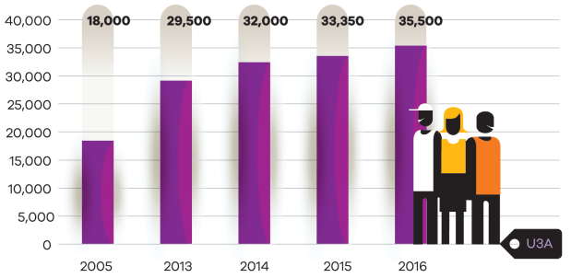
Source: U3A<https://www.u3avictoria.com.au/>

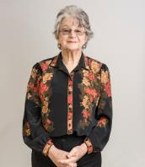
Volunteer profile: Gwen Smith, 2016 Premier’s Senior of the Year award winner
Gwen Smith has dedicated her life to making a difference to others, working in the community and in adult education for over 30 years to help people get back into training, work or community life.
As President of the Echuca Neighbourhood House, she is continually networking, searching for funding opportunities, holding planning meetings and seeking new ideas to get programs happening. She is heavily involved in the day-to-day running of the Neighbourhood House, and is a familiar face to all who attend programs there.
‘I believe that everyone has the right to education’, she says. ‘And there are many people who have not had the opportunity to learn to read and write, or use computers’.
Gwen is a passionate advocate for Neighbourhood Houses, and the volunteers who support them. ‘Neighbourhood Houses are doing more and more work to support the community. It’s not just about running courses. We couldn’t do it without a small army of volunteers’.
She is also a strong supporter of the Mirrimbeena Aboriginal Education Group, which she helped to found, and its work in supporting Aboriginal young people into training, education and employment. In addition, she is a member of the Echuca Returned and Services League, and is a judge for Town Crier competitions around Victoria.
Talking about her approach to life, she says, ‘One day at a time, do the best you can during that day. That’s how I’ve lived. And each day is its own reward’.

Volunteering in the lesbian, gay, bisexual, transgender and intersex community
Unfortunately, there is not much quantitative data on rates of volunteering in the LGBTI community. Anecdotal evidence suggests that many members of this community volunteer not only in LGBTI organisations, but across community-based organisations such as sports, arts, culture and heritage, welfare and community services.
The Victorian AIDS Council, which is probably the largest LGBTI organisation in Victoria, has 105 paid staff and 600 volunteers. This means that 85 per cent of their workforce is made up of volunteers.
Data from the first round of the Department of Premier and Cabinet’s LGBTI Community Grants Program shows that:
- over 60 LGBTI-specific organisations applied, with 57 organisations having zero to four paid staff
- the majority of LGBTI organisations have a small team of staff and a large volunteer base, mostly in the 90–100 per cent range

Sectors supported by volunteers
The breadth and diversity of the sectors supported by volunteers demonstrates the range of work that volunteers undertake across Victoria to ensure our communities are thriving, healthy and active.
Understanding these sectors in more detail will help us determine where further effort could be directed towards supporting volunteers.

Sport and recreation
According to 2014 ABS data, 32 per cent of volunteers (486,300 Victorians) volunteered for a sport and recreation organisation. These volunteers contributed a total of 47 million hours (ABS, 2015).
Over 231,000 Victorians (48 per cent of sport and recreation volunteers) reported contributing 50 hours or more per year, which equates to a minimum of nearly one hour per week.
Around 210,700 (14 per cent of all Victorian volunteers) reported their type of volunteering activity as coaching, refereeing or judging.
The 2010 ABS Volunteers in Sport survey (ABS, 2012) indicates that the number of volunteers could be as high as 580,000 Victorians.
This underscores the importance of sport and recreation for Victoria – across the state, our sport and recreation clubs knit together people and communities.
It also reflects the fact that sporting and recreation clubs are the engine room of volunteering – in 2014, 84 per cent of people who volunteered had also participated in organised team sport as a child.
Through participating in sport and recreation, people discover not only the personal health and wellbeing effects of an active lifestyle, but also the social benefits of volunteering. The data shows they often go on to fulfil a lifetime of community support through volunteering.

Volunteer profile: Warrandyte Tennis Club
Tony (51–65) took on the role of junior convenor at the beginning of 2010 when his daughter was playing junior competition, and continues to enthusiastically manage the junior teams even though it is several years since his daughter has played as a junior.
He has since been instrumental in the growth of the junior competition from five teams (20+ players) to 15 teams (60+ players). This growth has occurred even though there is an overall downward trend for tennis across the region.
He also helps in many areas that are not related to junior convening, such as maintenance, administration, marketing and fundraising.
Source: Premier’s Volunteer Champions Awards 2016

A large proportion of volunteering in the sport and recreation sector appears to be related to parenthood, and parents contribute significantly to support their children’s participation in school and community sport and recreation activities.
This is borne out by data such as:
- 39 per cent of nominees in the 2016 Premier’s Volunteer Champions Awards who reported volunteering for sport and recreation were aged 36–50, and a further 26 per cent were aged 51–65.
  - Australia-wide, couples with children (38 per cent) were more likely to be involved in volunteering than lone persons (25 per cent) or couples with no children (29 per cent) (ABS, 2015).
Children who participate in community sport and recreation clubs not only receive the benefits of healthy, active lifestyles – they grow up with parents who model the benefits of volunteering and provide an influence later in life.

Education and training
ABS data shows that 374,200 Victorians (25 per cent of volunteers) (ABS, 2015) volunteered for an education and training organisation.
In addition, 15 per cent of all Victorian volunteers reported spending most time on ‘teaching, instruction or providing information’ activities.
They contributed a total of 16 million hours (an average of 41 hours per year) (ABS, 2015).
This sector includes vital activities that bolster community cohesion, such as teaching English as a second language to migrant and refugee communities, providing homework support for children to improve their learning at school, and supporting parents to participate in school boards.
Volunteering in this sector also underscores another important benefit of volunteering: it can provide a link to the paid workforce. Adults volunteering in the education and training sector can share expertise from their paid workforce experience from wide-ranging sectors. Others gain new skills and knowledge from volunteering that may help them to obtain paid employment.
Volunteers in the education and training sector also provide expertise in cultural and community perspectives. See the following case study for an example.
Victorian Aboriginal Education Association Incorporated
The Victorian Aboriginal Education Association Incorporated (VAEAI) is the Victorian peak body, and the Department of Education and Training’s principal partner, for Koorie education.
Under the auspices of the VAEAI, over 30 Local Aboriginal Education Consultative Groups (LAECGs) provide an opportunity for a broad range of local Koorie community members to have a say on education and training matters that affect Koorie students.
These voluntary groups make a significant contribution by representing local community interests and Koorie perspectives in education. The LAECGs provide advice, monitor trends and issues, and advocate to improve education outcomes of Koorie people in their local communities.

In addition to adults undertaking voluntary activities in the education and training sector, students also undertake voluntary work linked to the school curriculum.
School community work (student volunteering) is voluntary community work that provides a direct benefit to the community and at the same time supports the students’ learning and career development. These activities are organised through the school and approved by the school principal as school community work. Generally, voluntary community work is available to students from year 9 and involves students aged 14 years and above. The department has developed resources to help schools arrange school community work, and to protect the health, safety and welfare of volunteer students. The student’s parent/guardian must provide informed consent for their child’s participation in school community work.
Volunteering in the education and training sector takes place in diverse settings, ranging from school-based settings, early childhood settings, other formal education settings as well as community organisations and associated settings.
Similarly, volunteer activities in this sector are diverse. In a schools-based setting, for example, volunteering includes (but is not limited to) ‘direct’ education-related activities such as supporting students with homework and classroom support as well as governance, fundraising/event management, policy development, coaching sport and ad hoc activities like providing adult supervision on excursions.
Volunteering in school-based settings also connects students to knowledge and skills that complement the school curriculum.
Furthermore, Victorian Government schools promote parent and community participation through school councils and parents’ clubs. There are approximately 540 parents’ clubs in Victoria, which represent around one third of Victorian Government schools. Collectively, these clubs raised an estimated $7 million in 2015.

Volunteer profile: Campbells Creek Primary School
Rachel is passionate about helping children in low socioeconomic communities develop their knowledge and skills to lead healthy and sustainable lifestyles.
Rachel and her team run a weekly gardening club at lunchtimes, where they teach students how to grow and harvest their own fresh food, as well as how to set up worm farms and composting systems.
Source: Premier’s Volunteer Champions Awards 2016

Welfare and community
In 2014, around 318,700 Victorians (22 per cent of volunteers) volunteered for a welfare and community organisation (ABS, 2015).
They worked a total of 36 million hours (an average of 114 hours per year, or over two hours per week) (ABS 2015). The large number of hours per volunteer in this category could be due to a larger proportion of volunteers being of retirement age.
For example, of nominations in the 2016 Premier’s Volunteer Champions Awards, 39 per cent of nominees who volunteered in welfare and crisis support were aged 66–80.
Volunteers in this sector undertake work that underpins social cohesion and social justice outcomes, such as crisis support and homelessness services, and connecting people to family violence responses.

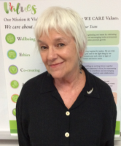
Volunteer profile: Home Start Mentors
Kietha has worked one-on-one with eight families and their children for the last eight years – focusing on both emotional and practical needs for the whole family.
Kietha has provided opportunities for these families to feel respected, supported and more connected to the community around them; assisting families to not be afraid to ask or seek out help when they or their children need it.
These families have also learnt the importance of early engagement with learning, language and literacy and their children have been introduced to community playgroups, kinder and schools, which has helped them start their journey towards lifelong learning.
Source: Premier’s Volunteer Champions Awards 2016

Religious
17 per cent of Victorian volunteers do so because of their religious beliefs (ABS, 2015).
Around 272,000 Victorians (19 per cent of volunteers) volunteered for a religious organisation.
Volunteers in this sector reported providing some of the most hours per week. They contributed a total of 48.6 million hours (an average of 179 hours per year, or nearly 4 hours per week) (ABS, 2015).
Volunteers in this category may also belong to an older cohort – 43 per cent of nominees in the 2016 Premier’s Volunteer Champions Awards who volunteered in the faith and religion category were aged 66–80 years.

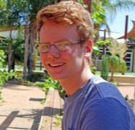
Volunteer profile: Nic Vine, Ouyen’s Junior Citizen of the Year 2016
For many teenagers, Sunday mornings mean sleeping in, sport, or maybe even study.
But for 17-year-old Nic Vine, every Sunday morning is an opportunity for him to give back to his small hometown in north-west Victoria.
The teenager was recognised for his volunteer work in Ouyen — particularly with junior sport and within his church community.
‘I just get involved with lots of things, so I've been involved with the brass band for nine years now, and I've done a fair bit with basketball like playing, umpiring, coaching and organising referees, and also footy and cricket’, he said.
But Nic's biggest volunteering commitment is to his church, recording services every Sunday for elderly or unwell people who cannot attend.
‘It's something my Pa started and he taught me how to do it before he passed away, and it was pretty touching thinking that he's done that for people that can't make it for various reasons’, Nic said.
‘If you can't make it, there's not much you can do, so if someone can provide a tape of the service it makes it a fair bit easier for them and they don't have to miss out on much’.
‘I enjoy going to church and talking to people, and you get involved with the community a fair bit through that’.
Nic said volunteering was a big part of his life, and something he saw as something to enjoy, rather than a chore.
Extract from: ABC News, Teenage church volunteer recognised in Ouyen <http://www.abc.net.au/news/2016-01-29/teenage-church-volunteer-recognised-in-ouyen/7125366>

Emergency services
Australia-wide, four per cent of volunteers work for an emergency services organisation, and three per cent of volunteers reported spending most time on a search and rescue, first aid, firefighting or community safety activity (ABS, 2015).
Summary results from the 2014 ABS General Social Survey (ABS, 2015) do not include state-level numbers for this sector, however the Emergency Management Volunteer Statement (Emergency Management Victoria, 2016) states that there are over 100,000 emergency management volunteers throughout the State across a wide range of agencies.
For comparison, four per cent of Victorian volunteers equates to approximately 60,000 people, yet the Country Fire Association (CFA) alone was comprised of 57,000 volunteers who are members of the CFA (CFA, 2015).
For rural and regional Victoria, the 2014 Regional Wellbeing Survey (Regional Development Australia, 2014) found that six per cent of volunteers in regional areas volunteer regularly (most weeks or more) for an emergency service organisation, far exceeding the average of two per cent across rural and regional Australia.

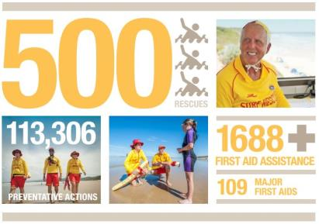
Source: Lifesaving Victoria Annual Report 2014-2015

Volunteer profile: Community Emergency Response Teams
Community Emergency Response Teams (CERTs) are located in less-populated and more remote areas of the state.
They co-respond to incidents with the nearest ambulance, and provide immediate care until the ambulance arrives. In 2014–15, CERTs arrived before an ambulance in 83.6 per cent of cases, illustrating the high value of these teams.
At 30 June 2015, there were 27 teams with a total of 404 volunteers.
Source: Ambulance Victoria Annual Report 2014–15, p. 16

Health services
Around 168,600 Victorians (11 per cent of volunteers) gave their time to a healthcare organisation (ABS, 2015).
They worked a total of 10 million hours (an average of 56 hours per year, over one hour per week).
Volunteers in this sector provide benefits not just to social cohesion, but also to health and wellbeing by undertaking roles such as transporting frail older people to medical appointments, and volunteering in hospital wards to provide support to patients and their families.
Volunteer profile: The Royal Women’s Hospital, oncology ward
Elaine is in her 80s, and for most of the 21 years she has spent volunteering at The Royal Women’s Hospital, she has worked in the oncology ward.
She provides support to nursing, clinical and administrative staff, helping to arrange and refresh flowers; ensuring cancer-related information is available for patients and their families, and unpacking the stores and small equipment orders.
Having Elaine as a volunteer means staff can focus on providing the best quality care, with the reassurance that Elaine is taking care of business behind the scenes.
Source: Premier’s Volunteer Champions Awards 2016

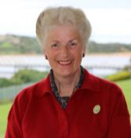
Volunteer profile: Lyndoch Living, Lyndoch Shopper service
Bev’s first introduction to volunteering at Lyndoch was through her mother, a long-term volunteer at Lyndoch who initiated the idea of offering ‘a personalised shopping service’ to residents.
Bev took over the role of Lyndoch Shopper 30 years ago, and has become a role model and mentor to a small team of volunteers to support this unique personalised shopping service that adds value to residents’ wellbeing and social connectedness.
The team of four Lyndoch Shoppers provide a personalised service to residents by purchasing a range of personal items as well as gifts for their family members.
In addition, Bev attends internal training programs to support volunteers in their roles and keeps herself updated on the broader care concepts in the aged care industry.
She always has time to stop and chat, giving that little bit of extra time to residents who may be feeling lonely or anxious.
Source: Premier’s Volunteer Champions Awards 2016

Disability services
Volunteers form a significant part of the disability services sector and are involved in either direct service or indirect service provision. Indirect service provision roles include administration, maintenance, information technology, finance and others.
Inclusion Melbourne (2016) reports that the 47 organisations that participated in their survey on the National Disability Insurance Scheme collectively engaged 5,175 volunteers to support 11,124 people with a disability.
The number of volunteers in disability organisations is likely to be much greater, as there are over 300 organisations in Victoria listed in the Department of Health and Human Services’ Register of disability service providers that mostly engage volunteers to serve their clients.
Moreover, Inclusion Melbourne states that 83 per cent of their respondents with disability observed differences between paid staff and volunteers, including increased social connections and community participation, genuine relationships and the value of lived experience.
Quote from survey respondent:
‘The relationship can be different, not time based or output focused. More fluid and changes with the needs of individual. Strong links to community’.
Source: Inclusion Melbourne, 2016, p. 14

Volunteer profile: Outlook Vic
Edie supports adults with intellectual disabilities and learning difficulties to participate in a pre-employment program.
She works one-on-one with people to help them find ways to understand and complete tasks, allowing participants to remain engaged and have a greater chance of succeeding.
Edie is able to relate and adapt to the varied skills, abilities, disabilities, behavioural issues and levels of understanding of the participants within the program.
There are participants in the class who are able to keep up with tasks due to her additional assistance and support.
Edie has also worked outside the classroom on many occasions and this has included assisting participants to be able to travel independently to and from classes, increasing skills and independence.
Source: Premier’s Volunteer Champions Awards 2016

Aside from many volunteers in disability organisations, 29 per cent of Australians with a disability had undertaken voluntary work, compared to the general population at 32 per cent (ABS, 2015).
In addition, the ABS (2015) data shows that 29 per cent of people with a disability provide informal support to relatives, compared with 26 per cent of those who have no disability.
People with a disability are also more likely to be carers of others with a disability, long term condition or old age at 22 per cent compared to 17 per cent for those without a disability.

Arts, culture, heritage
Across Australia, four per cent of volunteers volunteered for an arts or heritage organisation, and three per cent spent most time on a ‘performing or media production’ activity (ABS, 2015).
Summary results from the 2014 ABS General Social Survey (ABS, 2015) do not include state-level numbers. However, Creative Victoria research shows that volunteers contribute significantly to Victoria’s art, culture and heritage.
Across the organisations funded by Creative Victoria, volunteers provided over 530,000 hours, or the equivalent of 70,000 full days in 2014. They supported non-government arts organisations, museums and galleries, festivals, and state cultural organisations such as the State Library of Victoria (Creative Victoria, 2016).
It is important to note that the value of volunteers to the arts, culture and heritage sector value is greater than the number of hours they contribute.
This is because volunteering in this sector appears to have a flow-on effect for future community participation – more than half of all Victorian volunteers (52 per cent) had participated in arts, culture and heritage activities as a child.
The Cultural Development Network for example, is in the process of developing measurable cultural outcomes from volunteer engagement in cultural development activities and the value volunteers contribute to the cultural outcomes of others through their participation.
Volunteer profile: Hanging Rock Action Group
The Hanging Rock Action Group provided volunteers with a way to focus their energy on positive outcomes for Hanging Rock and for the local community.
The sustained efforts of this small group have ensured Hanging Rock will be protected for everyone.
The group advocated strongly for the interests of Hanging Rock to all levels of government and across the political divide.
They helped to secure $1 million in funding, and nominated and funded Hanging Rock’s successful inclusion on the Victorian Heritage Register.
The state government has since reviewed management arrangements, reformed the advisory committee and is currently developing a new Master Plan for the precinct.
Source: Premier’s Volunteer Champions Awards 2016

Environment and conservation
Australia-wide, four per cent of volunteers do voluntary work for an environment organisation (ABS, 2015).
The summary results from the 2014 ABS General Social Survey (ABS, 2015) do not include state-level numbers, but Victoria is home to many ‘friends of’ groups and community-based Committees of Management that focus on local places, landscapes and species.
In fact, volunteers have shaped and restored Victoria’s environment, advocating for its protection and implementing actions to conserve it.
Victoria has also provided national leadership with the establishment of Conservation Volunteers Australia in the early 1980s and Landcare in the mid-1980s, which both now support volunteer activities nationally and internationally in the environment sector.
During 2015, Conservation Volunteers Australia managed over 80,000 hours of volunteer effort to enhance Victoria’s natural capital, valued at over $2 million. Activities undertaken by volunteers included planting 150,000 trees, collecting seeds, removing pest plants, improving tracks and trails, and monitoring and supporting the recovery of threatened species (Conservation Volunteers Australia).
Many other volunteer groups contribute to a range of environmental outcomes, for example the Sporting Shooters Association undertakes pest animal control on public land, Field and Game has assisted in the protection and restoration of wetlands, and bushwalking clubs and four-wheel drive clubs maintain tracks and trails. The efforts of these volunteers often go unrecognised.
Parks Victoria reports that in 2015-16, 220,947 volunteers assisted through groups, as individuals and as community partners to enhance Victorian communities’ parks, reserves and waterways (Parks Victoria). The Coastcare Victoria program proudly supports hundreds of community volunteer groups working to protect and enhance Victoria’s 2000 kilometres of coastline.
Forty campground hosts provide campers and visitors with information and advice at campsites during peak summer periods, and 20 track rangers assist visitors with information and advice during summer in the Alpine area.

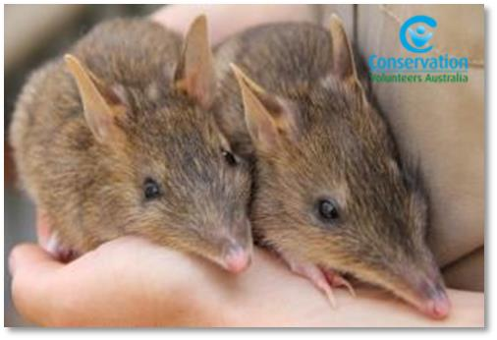
Case study: Eastern Barred Bandicoot recovery
Conservation Volunteers Australia’s inspiring Eastern Barred Bandicoot recovery effort demonstrates what well-managed volunteers can achieve.
Since the project’s inception, the Eastern Barred Bandicoot population is now thriving and has grown to over 150 animals.
Volunteer numbers have also grown from zero to an average of 800 volunteers a year. In addition, CVA has leveraged financial and in-kind support from over 25 businesses, valued at more than $270,000.
In 2010, CVA partnered with Parks Victoria to create a cross-sector partnership with the goal of reintroducing a captive-bred population of Eastern Barred Bandicoot at the Woodlands Historic Park, supported by community participation and education program, and managed by CVA.
The success of this project can be attributed to a number of factors, but of most significant is the on-ground support of volunteers.
Source: Conservation Volunteers Australia

Benefits of volunteering for Victoria
Volunteering delivers immense value to Victoria, across a number of domains, for communities, places and individuals.
In addition to the direct economic benefits provided by a formal volunteer workforce of 1,511,500 Victorians, volunteering has many direct and indirect benefits for the strength and resilience of Victorian communities.
As well as benefiting communities, it provides health and wellbeing benefits for people who volunteer, with altruism being associated with greater personal satisfaction, wellbeing and greater longevity.
Volunteering also has particularly important consequences for culturally and linguistically diverse and Aboriginal communities.

A stronger social fabric
Quantifying the contribution of volunteering to social cohesion is difficult, however a number of reports provide quantitative and anecdotal evidence to support the premise that volunteers build a stronger social fabric in Victoria.
In fact, volunteering, as a form of ‘participation’, is often used as a domain to measure social cohesion in many studies (see for example Marcus, 2015).
Central to this is the notion of social capital, which is defined as social networks that establish trust and connection in the community (Putnam, 1995).
The Victorian Council of Social Service states that volunteers allow community-sector organisations to build social capital, which thus increases community cohesion (VCOSS, 2015).
Victorian Government research also indicates that volunteering enhances social cohesion and strengthens our communities (DPCD, 2011).
The DPCD report shows that Victorians perceive the elements of an ideal community as including assets, amenity, connection, participation and strong governance (DPCD, 2011).
It also emphasises the role of social capital in the social and economic wellbeing of individuals, families or communities (DPCD, 2011).
The importance of volunteering for social cohesion is underlined by the fact that the vast majority (81 per cent) of Victorian community sector charities are supported by volunteers (VCOSS, 2015).

Cultural benefits
Recent research by the Cultural and Indigenous Research Centre (CIRCA, 2016) commissioned by the Commonwealth Government demonstrates that volunteering brings strong benefits for culturally and linguistically diverse (CALD) communities, and Aboriginal communities – even though members of these communities may not identify what they do as volunteering.

Culturally and linguistically diverse communities
CIRCA (2016) found that maintaining linguistic, social and cultural traditions was an important motivation for volunteering in CALD communities.
Many refugee and immigrant communities see voluntarily participating in activities that support cultural traditions and connection as an essential part of settling in a new culture.
As well as volunteering their time, participants in the research provided individual financial support for projects to maintain traditional social structures and relationships.
They also described volunteering as an inseparable element of their culture that needed to be passed on to the next generation, and shared with other Australian communities (CIRCA, 2016).
In addition, participants saw active participation in volunteer activities that extended past the needs of their own community as a way to share their identity with the broader Australian society (CIRCA, 2016).

Aboriginal communities
The CIRCA report also examines the significance of volunteering to Aboriginal communities, and finds that ‘sharing, giving and helping others are integral to Indigenous culture and play a key role in maintaining culture and traditions’ (CIRCA, 2016, p. iv).
Aboriginal participants in the research viewed cultural survival and cultural maintenance as important reasons to undertake voluntary work for their communities.
Quote from Aboriginal man:
‘Everyone volunteers for something, whether it is sport or politics. You learn from a young age, watching your family contribute and you grow up and you do that too – it’s an obligation but it’s good for your self-worth’.
Source: CIRCA, 2016, p. 44

Participants from remote communities also highlighted that looking after the land is an important responsibility that is done voluntarily (CIRCA, 2016).
Sport also plays a big role for many Aboriginal people, and many participants were involved in sporting activities within communities as well as through mainstream sporting organisations (CIRCA, 2016).
Participating in events by organising and serving food, running stalls, speaking, providing entertainment and childcare are also significant volunteering activities cited by many Aboriginal people (CIRCA, 2016).

Local Aboriginal Networks
In Victoria, the Department of Premier and Cabinet has established Local Aboriginal Networks (LANs), which are voluntary community networks that provide a safe and welcoming space for ‘the Aboriginal community to connect share, learn and lead’ (Department of Premier and Cabinet, 2016).
LANs set local priorities, develop community plans and improve social cohesion in Aboriginal communities.
They are facilitated by Aboriginal Community Development Brokers across the state, who broker partnerships between LANs and local stakeholders and support the development and implementation of community plans.
Through this program, the number of Aboriginal community members volunteering and participating in LANs has been increasing since 2009, and is projected to increase between 7 and 10 per cent by 2020.
Aboriginal Victoria reports that as at 30 June 2015, there were 2,109 volunteers/partners, making up approximately 6.1 per cent of Victoria’s Aboriginal community aged over 15 years.
Source: Department of Premier and Cabinet, 2016

Environmental benefits
Through ‘friends of’ groups, as well as organisations like Landcare and Coastcare, volunteers help to enhance and protect Victoria’s environmental assets, which provide the essentials of clean air, fresh water and fertile soil, as well as less tangible but vital benefits through spiritual and recreational activities.
This volunteer contribution is particularly important because Victoria’s biodiversity faces a number of threats, including invasive pests and weeds and a changing climate.
Protecting natural assets can help to slow floodwaters, reduce the risk of fire and protect against erosion, as well as cooling surrounding urban areas in summer and moderating strong winds.
Green spaces are also important for community wellbeing, and they contribute to cultural heritage, spiritual values and day-to-day living for Aboriginal and Torres Strait Islander peoples.

Economic benefits
The Department of Planning and Community Development (2012) estimated that volunteering contributions were worth about $23 billion to the Victorian economy in 2011, and are set to grow to as much as $42 billion by 2021 if rates of volunteering continue.
Table 1: Future projections of total value of volunteering in Victoria
Categories | 2006 ($ billion) | 2011 ($ billion) | 2016 ($ billion) | 2021 ($ billion)
Series A | 16.4 | 22.7 | 31.0 | 42.1
Series B | 16.4 | 21.4 | 27.8 | 35.7
Series C | 16.4 | 20.3 | 24.9 | 30.3
Source: Department of Planning and Community Development, 2012.
Note:
- Series A assumes that the total average hours of volunteering per adult continues to increase at the rate of 1.1 per cent a year (as they have done during the period 1992–2006).
- Series B assumes that the 2006 average hours remain unchanged.
- Series C assumes that the average hours decline by 1.1 per cent each year.
- All three scenarios are then combined with ABS population projections for Victoria.

Leveraging government services
Another important economic effect of the volunteer effort is the value that volunteers can add to government services. This is particularly relevant because the health and welfare organisations contracted to deliver community services often employ large volunteer workforces. There are also certain roles that are more suitable for volunteers because a paid employee may have a different perspective to that of a community member. See the following case study for an example.
In addition to this, the government also runs its own programs and events that involve volunteers, such as the annual Seniors Festival.
There are 240 Bail Justices and 3,860 Justices of the Peace supporting Victoria’s justice system.
Volunteer profile: Independent Prison Visitor Scheme
Independent Prison Visitors (IPVs) are volunteers appointed by the Minister for Corrections to provide independent objective advice about the operation of Victoria's prison system from a community perspective.
IPVs visit their designated prison each month to observe prison operations and to interact with prisoners, staff and visitors.
The IPVs submit a report of their observations and any matters raised to the Office of Correctional Services Review for analysis after each visit.
The costs of the scheme include those incurred by volunteers, as well as training and development costs and departmental salaries to enable administration of the scheme. The value of the information that IPVs provide in terms of independent advice to government is arguably well in excess of these costs.
Source: Office of Correctional Services Review

Benefits for individuals
It is also important to note that as well as providing benefits for others, volunteering provides many benefits for volunteers themselves.
For example, one of the reasons people cite for volunteering is social contact (41 per cent of volunteers) (ABS, 2015).

Health and wellbeing
According to Volunteering Australia’s Key facts and statistics about volunteering in Australia (Volunteering Australia, 2015), volunteering is associated with greater health and happiness – 95 per cent of volunteers say that volunteering is related to feelings of wellbeing.
The report also shows that:
- just a few hours of volunteer work make a difference in happiness and mood
- sustained volunteering is associated with better mental health
- altruistic emotions and behaviours are also associated with greater wellbeing, health and longevity (Volunteering Australia, 2015).

Pathways to employment
According to research cited in the Department of Planning and Community Development report Indicators of community strength in Victoria: framework and evidence (2011), networks developed through formal types of participation, such as education and volunteering, can help to connect people to career paths, and to labour markets that are better paid and more stable.
ABS data shows that learning new skills (23 per cent) and gaining work experience (11 per cent) are significant reasons that people cite for volunteering, as well as providing opportunities for people to use their skills and experience (32 per cent) (ABS, 2015).

People in lower socioeconomic areas
The Department of Planning and Community Development (2011) found that volunteering can mediate the negative psychological effects of disadvantage.
The research cited shows that volunteers from disadvantaged backgrounds had similar levels of psychological wellbeing as professional, educated non-volunteers.
In addition, students from disadvantaged backgrounds who were involved in activities such as clubs, bands or volunteer work had the highest rates of healthy behaviours and the lowest rates of risky behaviours.

Opportunities
Despite the challenges, there are many opportunities for strengthening volunteering and ensuring it remains relevant and sustainable into the future.
New technologies provide new ways for people to engage and to control the way they interact with formal volunteering opportunities.
‘Voluntourism’ is a burgeoning industry that allows people to forge meaningful connections with communities when they travel. ‘Timebanking’, where people can ‘bank’ hours they volunteer in exchange for others’ services, is a new community model being explored in New South Wales.
There are also opportunities to improve volunteering rates among disadvantaged communities, particularly culturally and linguistically diverse communities and areas of low socioeconomic status – which are communities that stand to benefit from the social cohesion and health and wellbeing benefits that volunteering can provide.
These and other changes present opportunities for us to address stagnant rates of volunteering and ensure the benefits of volunteering continue to be shared for years to come.

Volunteer expectations are changing
According to Volunteering Australia’s State of volunteering in Australia 2012, Australians are asking for a wider range of ways to volunteer (Volunteering Australia, 2012).
They want meaningful volunteer roles and greater flexibility in how and when they volunteer under different circumstances that arise in their lives.
This includes:
- episodic volunteering
- online volunteering
- skilled volunteering
  - volunteering through the workplace.
These few examples demonstrate the extent of the changing landscape of volunteering.
Harnessing these expectations through technology can increase the extent to which people are prepared to volunteer.
Volunteer profile: Digital technology
Dr Nigel Taylor ESM, CEO Lifesaving Victoria, is looking to the future.
He says, ‘Digital technology is playing an ever-increasing part as Lifesaving Victoria looks to improve member connectedness, streamline problematic processes, expand the reach of education and training programs and create efficiencies’.
Source: Lifesaving Victoria, Annual Report 2014/15, p. 5

The role of leaders
The key to managing emerging challenges and expectations in volunteering is the role of leaders and managers of volunteers.
Regular monitoring and evaluation of volunteer programs being funded by the government – including looking at best practice in the management of volunteers - could inform approaches to ensure programs are more responsive to the changing volunteering landscape.
Leaders and managers of volunteers, in particular, are in a unique place to effectively contribute to ongoing development of a resilient and sustainable volunteering sector in Victoria.

Intergenerational influence and childhood participation
Another opportunity to strengthen and promote volunteering is via the intergenerational influence of parents who volunteer and instil altruistic behaviour in their children.
The 2014 General Social Survey (ABS, 2015) reported that 43 per cent of people who volunteered had done some form of volunteering as a child, and 75 per cent had a parent who had done voluntary work.
Figure 11: People who volunteered in the last 12 months, whether parents participated in voluntary work, 2014
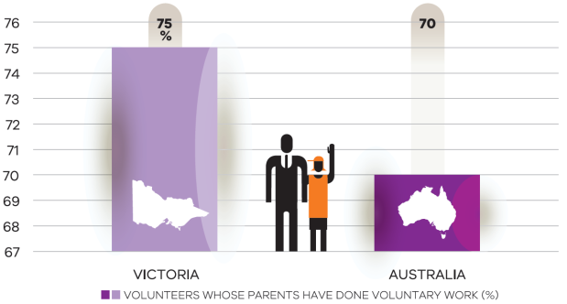
Source: General social survey 2014 (ABS, 2015)
People who volunteered were also more likely to have participated in organised team sport and other community-focused activities as children.
Volunteers reported participation in organised team sport (84 per cent), youth groups (62 per cent) and arts/cultural activities (52 per cent) as a child.
Figure 12: People who volunteered in the last 12 months, activities participated in as a child, 2014
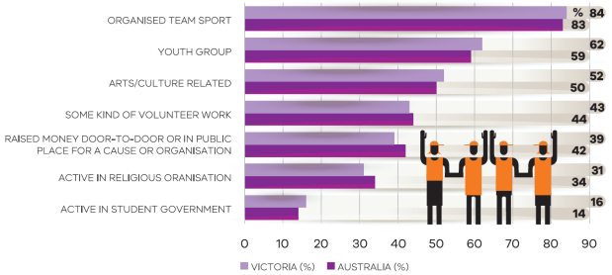
Source: General social survey 2014 (ABS, 2015)
This data shows that our sporting clubs and other community activities are the engine room of volunteering in Victoria.
Providing opportunities and supporting people to get involved with volunteering and community activities at a young age can help to ensure that people will go on to give back to the community later in life.
The ABS (2014) however reports that Victorians aged 15-17 have the lowest rate of volunteering at 25% compared to the Australian figure of the same cohort at 41%. Similarly, 18-24 year old Victorians have a low rate of volunteering at 28%.
There is an opportunity to further engage young people in volunteering, which is known to develop networks and help to connect people to career paths, and labour markets that are better paid and more stable.
The Ministerial Council for Volunteers could work with a range of partners to develop strategies and policy recommendations. This could include investigating certified training for volunteering, engaging more CALD and Indigenous youth, and using more innovative approaches including through technology and targeted engagement opportunities (e.g., through music, sports, and environmental causes).

Improving rates of volunteering among disadvantaged communities
We know that people from low socioeconomic areas have lower reported rates of formal volunteering, and this presents us with an opportunity to boost volunteering among these communities.
The 2012 State of volunteering in Australia (Volunteering Australia, 2012) report found that the rate of volunteering in Australia is impacted negatively by variables including:
- whether a language other than English is spoken at home
- fair or poor self-assessed health
- being in a household where a government pension, benefit or allowance is the main form of income
- not completing a qualification after school
- having a disability or long-term health condition.

Low volunteering rates among Victoria’s most disadvantaged
Given the known benefits of volunteering for general health and wellbeing, and as a pathway to employment, the rate of volunteering among Victoria’s poorest is an opportunity for improvement.
Victoria ranks poorly on formal volunteering rates for people in the lowest quintile of gross household incomes, with just 21 per cent participation.
New South Wales, South Australia, Tasmania and Western Australia all do better on this metric, with between 24 per cent and 26 per cent volunteering rates in the lowest-income households.
Disadvantaged and metropolitan Melbourne growth areas have the lowest rate of volunteering including Brimbank (10%), Greater Dandenong (11%), Maribyrnong (15%), Wyndham (13%), Melton (12%), and Casey (13%).
Government and its partners, including local government, could build on opportunities to develop place-based solutions to address low rates of volunteering in these areas.
Figure 13: Volunteering rate in lowest quintile of household income, 2014
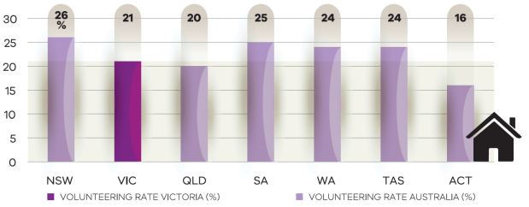
Source: General social survey 2014 (ABS, 2015)

High growth and diversity
Figure 9 shows that some areas with the lowest reported volunteering rates are also some of the most disadvantaged in Victoria.
These areas tend to be more urban and/or growth areas, and all report high or very high proportions of people who speak a language other than English (LOTE) at home.
Victorian data shows that a high proportion of LOTE speakers within the population is more likely to be associated with a low reported rate of volunteering rather than level of disadvantage.
The CIRCA report (2016) shows that there is under-reporting of volunteering rates among culturally and linguistically diverse (CALD) and Indigenous communities as ABS census and other censuses do not capture informal volunteering.
Given the high cultural diversity of these areas, a level of under-reporting is expected because people in these communities may not self-identify as volunteers, so the true amount of informal time given in these communities is unknown.
Targeting these areas to support volunteers – in terms of formal, informal and community volunteering – can yield strong benefits for Victoria’s social cohesion.
There is opportunity to generate more understanding and develop strategies to address the barriers to volunteering including reasons why people from diverse and disadvantaged areas don’t volunteer or don’t self-report informal and community volunteering.
There may also be a need to update ABS and other census instruments to improve the capturing of informal volunteering in these communities.

Rural and regional Victoria
The relationship between the rate of volunteering and disadvantage appears to be reversed in rural and regional Victoria.
Local government areas with the highest reported volunteering rates also recorded some of the highest levels of disadvantage, and all are in rural or regional Victoria and have a low percentage of people from culturally and linguistically diverse communities.

Online resources for volunteers
The use of social media, online volunteering services and other information and communication technologies are slowly but surely changing the face of volunteering.
In Victoria, there are volunteering organisations with websites providing support and information to prospective volunteers as well as resources for managers.
Volunteering Victoria’s HelpOut is an example of an innovative online recruitment service for emergency and recovery volunteers. The database contains a list of volunteers who can be matched with organisations working in disaster-affected communities.
GoVolunteer.com.au is another online platform owned by Volunteering Australia that aims to match volunteers with appropriate volunteering opportunities.

Conclusion
Victoria gains immense benefits from its volunteers, not just from the economic contribution that volunteers make, but also from enhanced social cohesion and environmental, spiritual and health and wellbeing outcomes.
However, demographic and cultural changes put these benefits at risk if we do not act to support volunteering.
This means governments, communities, businesses and the not-for-profit sector working together to sustain and improve rates of volunteering, particularly among key demographics and in key geographic areas.
By harnessing existing supports and practices and building upon available opportunities, all levels of government, together with the community, not-for-profit sector and businesses, can work together to ensure Victoria has a strong culture of volunteering into the future.

References
Australian Bureau of Statistics 2015, General social survey: summary results, Australia, 2014, cat. no. 4159.0, Australian Bureau of Statistics, Canberra.
Australian Bureau of Statistics 2011, Voluntary work, Australia, 2010, cat. no. 4441.0, Australian Bureau of Statistics, Canberra.
Australian Bureau of Statistics 2007, Voluntary work, Australia, 2006, cat. no. 4441.0, Australian Bureau of Statistics, Canberra.
Australian Bureau of Statistics, Census 2011
Australian Bureau of Statistics 2012, Volunteers in Sport, Australia, 2010, cat. no. 4440.0.55.001, Australian Bureau of Statistics, Canberra.
Australian Institute of Health and Welfare 2014, Australia’s mothers and babies 2012, AIHW, Canberra.
Australian Unity and Deakin University 2015, What makes us happy? Third edition, Australian Unity and Deakin University, Melbourne.
Ambulance Victoria 2016, Annual Report 2014-15, Ambulance Victoria, Melbourne.
Lifesaving Victoria 2016, Annual Report 2014-15, Lifesaving Victoria, Melbourne.
Cultural and Indigenous Research Centre Australia 2016, Giving and volunteering in culturally and linguistically diverse and Indigenous communities, Commonwealth Department of Social Services, Canberra.
Commissioner for Senior Victorians 2016, Ageing is everyone’s business, State Government of Victoria, Melbourne.
Country Fire Authority 2015, Annual report 2014–15, CFA, Melbourne.
Creative Victoria 2016, ‘Volunteers’, <http://creative.vic.gov.au/research/data/volunteers>
Department of Health and Human Services 2017, Victorian Population Health Survey 2014, State Government of Victoria, Melbourne.
Department of Planning and Community Development 2011, Indicators of community strength in Victoria: framework and evidence, State Government of Victoria, Melbourne.
Department of Planning and Community Development 2012, Economic value of volunteering in Victoria, State Government of Victoria, Melbourne.
Department of Premier and Cabinet 2016, Victorian Local Aboriginal Networks: five-year plan 2016–2020, State Government of Victoria, Melbourne.
Emergency Management Victoria 2016, Emergency Management Volunteer Statement, State Government of Victoria, Melbourne. <https://www.emv.vic.gov.au/volunteerstatement>
Inclusion Melbourne 2016, Volunteering and the National Disability Insurance Scheme: a discussion paper, Inclusion Melbourne, Melbourne.
Marcus A 2015, Mapping social cohesion: the Scanlon Foundation Surveys 2015, Monash University, Melbourne.
Putnam R 1995, ‘Bowling alone: America’s declining social capital’, The Journal of Democracy, vol. 6, no. 1, pp. 65–78.
Regional Development Australia 2014, Regional wellbeing survey 2014, data tables.
Schirmer J, Mylek M, Peel D, Yabsley B 2014, People and communities: the 2014 regional wellbeing survey, University of Canberra, Canberra.
U3A Nunawading 2016, ‘U3A Nunawading’, <www.u3anunawading.com.au>.
Victorian Council of Social Services 2015, Building on the value of Victoria’s community sector, VCOSS, Melbourne.
Volunteering Australia 2012, State of volunteering in Australia 2012, Volunteering Australia, Canberra.
Volunteering Australia 2015, ‘Definition of volunteering’, <www.volunteeringaustralia.org/policy-and-best-practise/definition-of-volunteering>, Volunteering Australia, Canberra.
Volunteering Australia 2015, Key facts and statistics about volunteering in Australia, Volunteering Australia, Canberra.
Volunteering Victoria 2016a, ‘Purpose and vision’, <volunteeringvictoria.org.au/our-purpose-and-vision>.
Volunteering Victoria 2016b, ‘Victorian volunteer support organisations’, <http://volunteeringvictoria.org.au/wp-content/uploads/2011/10/Victorian-Volunteer-Support-Organisations-List-March-2016-2.pdf>.

