## Report-cover-3

|  |
| --- |
| Leadership in volunteering survey  Key findings and improvement opportunities |

|  |
| --- |
|  |
| To receive this publication in an accessible format [email Volunteers Council](mailto:volunteers.council@dhhs.vic.gov.au) <volunteers.council@dhhs.vic.gov.au>  Authorised and published by the Victorian Government, 1 Treasury Place, Melbourne.  © State of Victoria, Ministerial Council for Volunteers, June 2017.  ISBN 978-0-7311-7259-7 (online/MS word)  Available at [Ministerial Council for Volunteers](http://www.providers.dhhs.vic.gov.au/ministerial-council-volunteers)<www.providers.dhhs.vic.gov.au/ministerial-council-volunteers> |
|  |

Contents

**The leadership in volunteering survey 5**

Key points identified by the survey for organisations 5

Respondent demographics 7

Location 7

Position in the organisation 8

Qualifications 8

Salary 9

Sector 10

Number of volunteers 10

Remuneration 11

Paid/unpaid status and qualifications 11

Reporting lines 11

Metropolitan versus rural remuneration 12

Reasons for being a volunteer leader 12

Professional development 13

Professional development needs 14

Professional development budget 14

Most common avenues for support 15

Valuing of volunteers 16

Volunteers’ duties 16

Perceptions of value placed on volunteers 16

Technology and social media 18

Communication with volunteers 18

Improvement opportunities 19

Improving how leaders of volunteers are respected and supported by their organisations 19

Improving the way leaders of volunteers are respected and supported by the community 21

General comments 22

# The leadership in volunteering survey

The Ministerial Council for Volunteers (the Council) conducted a survey late in 2016 to seek the views of those who lead or coordinate volunteers. The purpose of the survey was to inform the Council’s views on strengthening and supporting volunteer leadership in Victoria.

## Key points identified by the survey for organisations

### Valuing/recognition of volunteers

* Genuine demonstration that an organisation values all staff and volunteers promotes workplace health and wellbeing, morale, improves productivity and efficiency, and reduces staff turnover and associated costs.
* Costs of not valuing staff and volunteers can be significant (e.g., dispute resolution, hiring, training and induction, loss of productivity, and costs related to other staff temporarily filling in roles).
* **The survey data** highlights that many leaders of volunteers are reporting at relatively low levels into their organisations, do not feel fully supported or that senior management is accessible, and do not feel that their workload and skills are recognised in comparison to paid staff.
  + A range of easily implemented and low cost strategies exist to improve how leaders of volunteers are recognised and valued in an organisation. The National Standards for Volunteer Involvement provides you and your Managers/HR area with good practice guidance that will help to manage risks in your organisation, improve productivity and reduce costs (especially 1: Leadership and management; 2: Commitment to volunteer involvement; 5: support and development; 7: Volunteer recognition).

### Training/education

* Well trained and supported staff help your organisation fulfil its mission and are happier in their roles.
* Research shows that staff who do not feel sufficiently trained or supported in their role suffer from higher stress levels and poorer workplace mental health, which impacts upon productivity, sick days taken, turnover and organisational reputation.
* Staff and volunteers working for your organisation who are not sufficiently trained to fulfil their duties may represent several significant risks, including to the organisation’s finances, reputation and ability to secure government or private funding.
* Where untrained staff and volunteers interact with the public, including vulnerable clients and community members, there is a very real risk of unintended/inappropriate behaviour leading to avoidable harm to individuals and the organisation. In addition, **the survey data** highlights that many leaders of volunteers are reporting in at a very junior level in the organisation – despite their often large workload and volunteer supervisory role – which raises questions over their level of appropriate managerial supervision.
* **The survey data** highlights that many staff ‘fell into’ their role of managing volunteers or that this was an ‘add-on’ to their other duties. Managing volunteers and their programs requires similar management skills to managing staff and programs in other areas of the organisation, and many respondents did not feel sufficiently well trained – many reported the need for leadership and governance training, and for networking opportunities with other volunteer leaders.
* **Many survey respondents**, particularly those in unpaid roles, reported having no budget available for professional development for themselves or the volunteers they oversee. The training and development needs of leaders of volunteers, whether paid or unpaid, are just as real as for other staff in the organisation. Well trained staff and volunteers will significantly reduce risks to the organisation and best assist it to fulfil its mission.
  + The National Standards for Volunteer Involvement provides you with good practice guidance and a framework that will help to support volunteers and their managers on an even footing with other staff in your organisation (especially 5: support and development).

### Investing in efficiency and competitiveness

* Organisations naturally utilise a range of different technologies to manage business operations, and internal and external communication. Failing to maintain current awareness of available technologies, and implement these where appropriate, can leave an organisation behind its competitors in terms of its efficiency, and can make it less attractive and accessible to staff, volunteers and clients.
* Social media is a set of ‘game changing’ technologies, utilised by growing numbers of the community to communicate formally and informally, quickly and efficiently. Its utilisation in the workplace has not kept pace with its use in the community, meaning that organisations are often not engaging effectively with the community and to the fullest extent, often relying on older methods that are now less relevant.
* **The survey data** highlight that use of social media to attract and engage volunteers is variable. Some organisations, for example, report that ‘facebook’ is a major tool in managing their ‘community’ of volunteers, while others report not utilising social media at all. The survey and other data suggests that organisations are slow to pick up on the benefits of social media due to a lack of understanding of how it works and its costs, benefits and risks.
* Engaging people through social media maintains currency with use of technology in the community, and in particular allows for organisations to ‘tap into’ the youth volunteer market.
* A range of low cost solutions can be implemented easily with minimal training, to improve your engagement and management of volunteers, and communication with the community more broadly.

# Respondent demographics

The survey was conducted online, with the link sent out through variety of channels by the Leadership Sub-Committee of the Ministerial Council for Volunteers and its Secretariat. A total of 416 responses were received. Notably, approximately 70 per cent of respondents requested to be kept informed about the survey’s findings and provided their contact details.

## Location

The survey achieved a wide statewide coverage (see Figure 1), with approximately one-third of respondents working in regional areas (see Figure 2).

Figure 1: Respondents’ location

This map illustrates the statewide coverage of the survey respondents, including locations such as Mildura, Bairnsdale, Wodonga and Hamilton.

Figure 2: Respondent’s location: Metropolitan/Regional

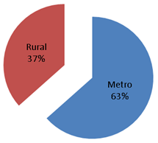

## Position in the organisation

The majority of respondents described their role as either Coordinators, Team Leaders, or Managers (Figure 3).

Figure 3: Respondents’ position in their organisation

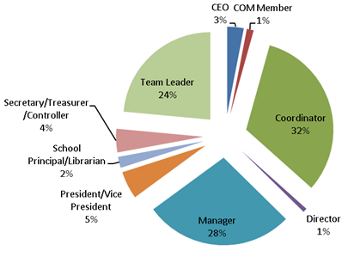

## Qualifications

Respondents were reasonably highly educated, with well over half having degree level or higher qualifications. The categorisation of educational level has been based on the Australian Standard Classification of Education (Figure 4).

Figure 4: Respondents’ qualifications

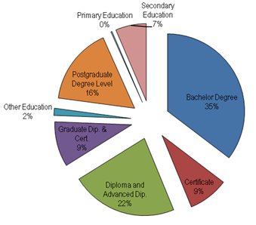

## Salary

Approximately two-thirds of respondents were in paid positions within their organisation (Figure 5). Of those that were paid, annual salary averaged most commonly fell between $50,000 and $74,999 (Figure 6).

Figure 5: Respondents’ status as paid or unpaid

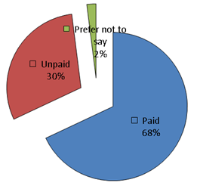

Figure 6: Paid respondents’ annual salary

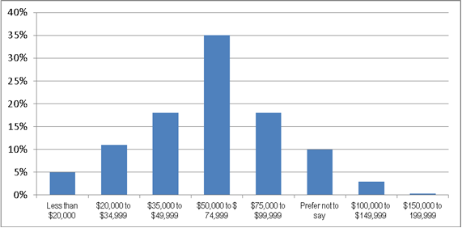

## Sector

Respondents were spread across a range of community sector organisations, with the dominant sector represented being ‘welfare and community services’ (Figure 7).

Figure 7: Respondents’ sector

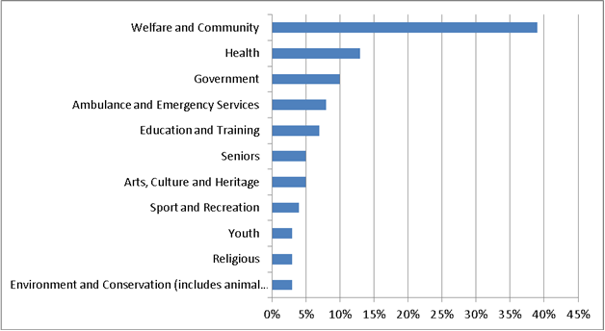

## Number of volunteers

Reflecting the diversity of organisations covered by the survey, respondents indicated a wide variety in the number of volunteers under their leadership or coordination (Figure 8).

Figure 8: Number of volunteers in the organisation

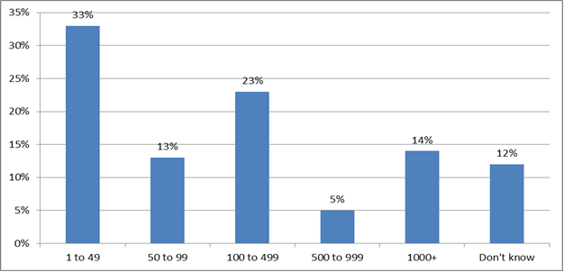

# Remuneration

## Paid/unpaid status and qualifications

It can be seen in Figure 9 (below) that there is a trend for respondents with lower level qualifications to be more likely to be in unpaid roles. It is noteworthy, however, that among paid respondents there is no statistical relationship between level of qualification and level of salary.

Figure 9: Relationship between qualifications and status as paid or unpaid

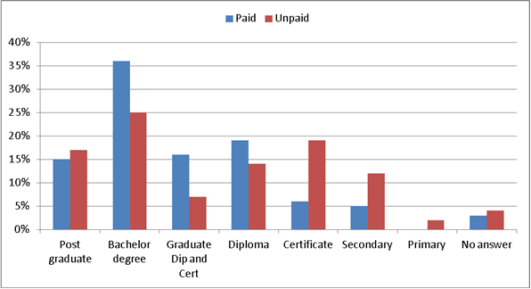

## Reporting lines

There was a trend observed that those reporting to more senior positions in the organisation were more likely to be in paid roles, with unpaid respondents largely reporting to junior (or no) staff (Figure 10).

Figure 10: Reporting line by paid/unpaid status

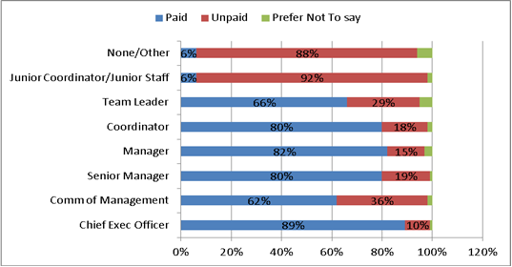

## Metropolitan versus rural remuneration

It is notable that there was no observable difference between metropolitan and regional respondents as to whether they were paid or unpaid – in both areas approximately one-third were unpaid. A greater proportion of paid regional respondents, however, fell within the average annual salary range (Figure 11).

Figure 11: Annual salary by location

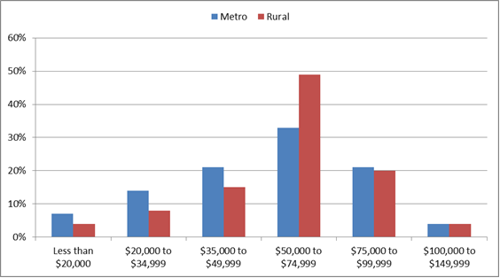

## Reasons for being a volunteer leader

The survey results suggest that those in unpaid roles are more likely to be in those roles due to an existing passion for volunteers and volunteering, or due to a family history of volunteering. While approximately one-fifth of paid respondents actively sought their leadership role, over 50 per cent did not (Figure 12).

Figure 12: Reasons for being a leader of volunteers by paid/unpaid status

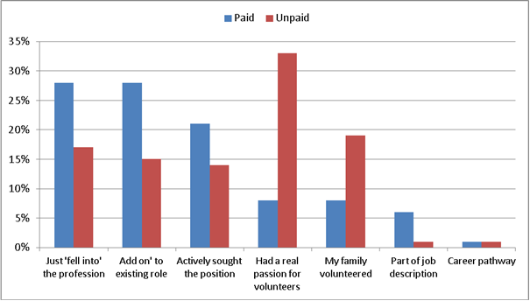

# Professional development

## Professional development needs

The survey found that approximately three-quarters of respondents identified a desire for more networking opportunities with other volunteer leaders. Also rated highly was leadership training (Figure 13). Approximately one-quarter reported a need for formal, or ‘other’, training (the latter including training on general industry standards, presentation skills, governance, legislative requirements, advocacy, and industry specific skills).

Figure 13: Reported professional development needs

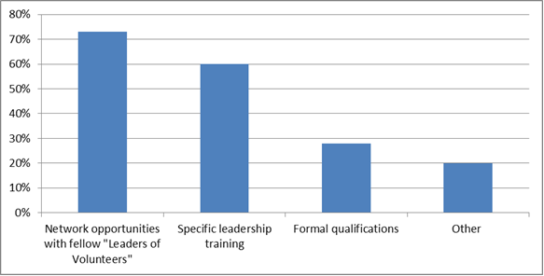

## Professional development budget

The survey identified that respondents were approximately equally divided (Figure 14) on whether or not they had an allocated budget for their own professional development (similar findings were made in relation to availability of budget for their teams’ professional development).

Figure 14: Availability of budget for leaders’ professional development

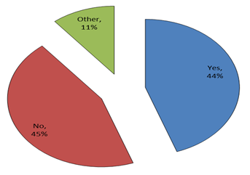

Figure 15 highlights that unpaid leaders of volunteers were substantially more likely to report having no budget for professional development.

Figure 15: Availability of budget for professional development by paid/unpaid status

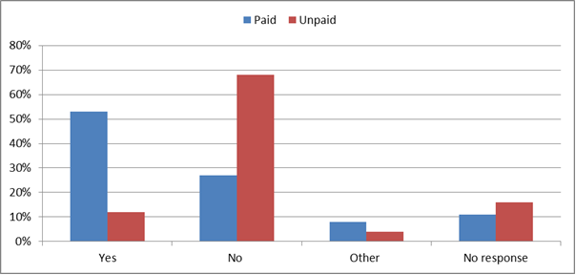

## Most common avenues for support

Respondents were also asked where they usually went for support in their roles, with almost three-quarters reporting obtaining support internal to their organisations. Slightly over one-third reported seeking support from a range of other sources, including other leaders of volunteers and formal volunteering support bodies. (Figure 16).

Figure 16: Most utilised options for support

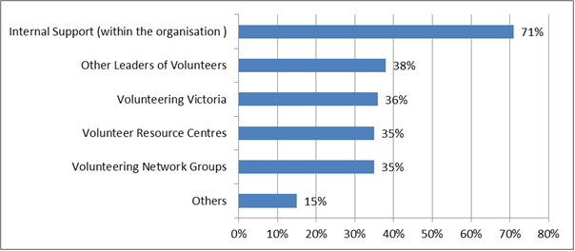

# Valuing of volunteers

## Volunteers’ duties

Respondents indicated that volunteers contributed a large range of support to their organisations, being most likely to play a role in multiple roles across the organisation rather than isolated areas (Figure 17).

Figure 17: Contributions of volunteer to organisations.

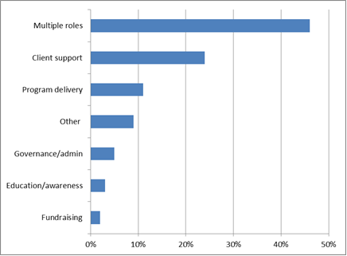

## Perceptions of value placed on volunteers

Most respondents agreed that their organisation valued volunteers, although there is a concerning minority of 12% who perceived that their organisation viewed volunteers as unimportant (Figure 18).

Figure 18: Respondents’ perception of organisational valuing of volunteers

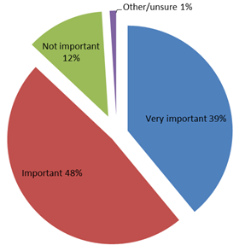

There is little difference between paid and unpaid respondents on this measure, although slightly more unpaid leaders of volunteers felt that their organisation valued volunteers (Figure 19).

Figure 19: Respondents’ perception of organisational valuing of volunteers by paid/unpaid status

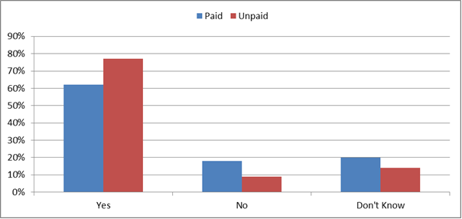

# Technology and social media

## Communication with volunteers

Respondents were asked how they communicated with the volunteers under their leadership / coordination (Figure 20). The clear majority utilised Facebook. ‘Other’ responses included a large number of invalid responses, however also included a range of web, email and SMS-based methods.

Respondents who were less likely to utilise ICT tools were often from smaller volunteer organisations (less than 100 volunteers) and in regional and disadvantaged areas, highlighting a potential opportunity to improve engagement with volunteers in these areas.

Figure 20: Methods of communication with volunteers

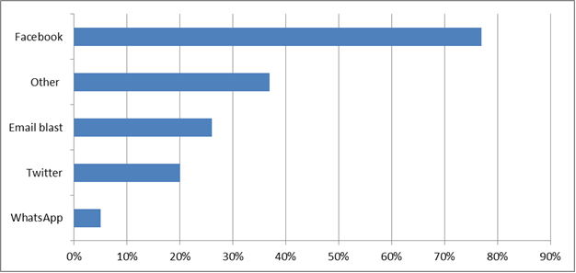

Studies have shown (e.g., O’Mara, 2009) that use of Information Communications Technology can be an effective way of empowering CALD communities, seniors, youth and disadvantaged communities.

It is potentially particularly useful in communicating with and organising volunteers giving the growing ownership of Smartphones in Australia, which increased from 11.1 million in 2013 to 15.3 million in mid-2015 (IAB Australia/Nielson, 2015).

Australian Smartphone users interact with their phone 480,000 Million times per day (Deloitte, 2016), and increasingly, volunteers will find it most useful to interact with both their host organisation, and their ‘clients’, utilising these devices.

# Improvement opportunities

The survey offered respondents a number of free text questions to generate suggestions for improvement. Of the more than 400 respondents, most chose to provide suggestions for each of the free text questions.

The free text responses have been coded into themes to facilitate analysis of the improvement ideas (see details for each individual question below).

Across all the free text questions, the highest frequency of improvement ideas are covered by these themes:

* Valuing/promoting
* Infrastructure
* Recognition
* Training
  + Funding

## Improving how leaders of volunteers are respected and supported by their organisations

Respondents offered a range of areas in which the Council could assist in improving the way in which they are supported in their organisations (Figure 21). Highlighted quotes within some of the main themes identified are provided below.

Figure 21: Suggested areas in which the Council could assist leaders of volunteers in their organisations

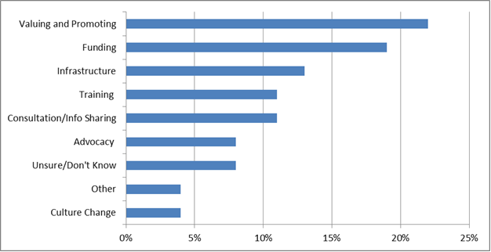

### Highlighted quotes

|  |
| --- |
| Valuing and promoting:  I am very lucky in my organisation to be recognised. However I see that in other organisation the volunteer leaders are expected to manage volunteers ‘on the side’. I feel we need to raise the profile of volunteer leaders and that managing volunteers is not an easy job and takes a lot of knowledge and skill and support.  Informing government about the role of Volunteer managers, and the many benefits of volunteering (aside from 'aren't they wonderful!') in terms of social inclusion, employment pathways etc. How important volunteering is at different levels- to the client, the program, the organisation, the volunteer and the community at large.  In my organisation, supervising volunteers is not regarded with the same importance as supervising staff. As such I am not paid the same wages as other staff supervising a similar number. I would argue that supervising volunteers is a lot more difficult than supervising paid staff as volunteers can just up and leave if they want whereas staff are working as they need the money. |

|  |
| --- |
| Funding:  More financial support for a community development approach to volunteering - there is not enough focus on building and valuing volunteers as a community and giving them opportunity to celebrate/network/belong.  Provide the necessary funding for us to do our jobs properly. Volunteering contributes a significant amount to the economy but the funding is simply not there to support Volunteer Leaders. We are expected to do more with less. |

|  |
| --- |
| Infrastructure:  By making the role one of Manager, which will enable participation at a decision making level. Being a sole worker, 'Coordinator' does not cover the scope of duties as is not recognised as the same as a HR role, even though a multitude of other skills are required.  By benchmarking and allocating a reasonable EFT guides for management. Some organisations have 2 EFT for 200 volunteers, some have .8 EFT for 300 volunteers. An equitable way of guiding resources would be very beneficial. |

|  |
| --- |
| Training:  Assist in the development of training to keep the sector progressing in new ways of engaging communities in volunteering and embedding volunteering and new models of volunteering in communities.  Acknowledgement of $ value Volunteers bring to the organisation, provide opportunities for training for leaders of volunteers and also for the volunteers themselves. Provide adequate budget that allows for training of volunteers and also allows for means to say thank you to the volunteers, via morning teas, lunches, flowers, thank you cards. |

## Improving the way leaders of volunteers are respected and supported by the community

Respondents also offered a range of areas in which the MCV could assist in improving the way in which leaders of volunteers are recognised and supported by their communities (Figure 22). Highlighted quotes within some of the main themes identified are provided below.

Figure 22: Suggested areas in which the MCV could assist leaders of volunteers in their communities

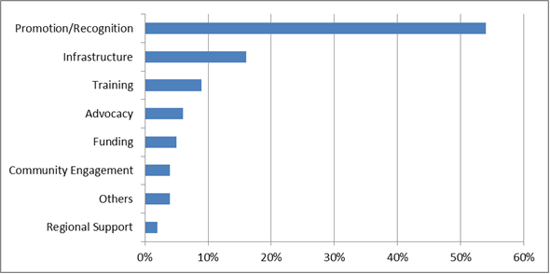

### Highlighted quotes

|  |
| --- |
| Promotion and recognition of leaders of volunteers:  Again promotion and marketing is essential. If people don't know about ‘us’ then how can they support ‘us’? Volunteering and the management of must be promoted as an essential component of the community. Eg. the CFA is the largest volunteer org in the state, who manages or leads the volunteers, who supports the development of the volunteers? It is never mentioned in the media. I attended a fantastic session at the National Volunteering Conference in Canberra that highlighted the work done throughout the CFA in empowering all volunteers, let’s hear about these stories, story telling is a very powerful tool.  Promote awareness of all the tasks volunteers leaders do. Often I get asked what I do all day. The perception is that managing volunteers is a really easy task. Most of the community don't know the amount of admin, background checks, coordination, conflict management, planning etc that goes into running a volunteer program |

|  |
| --- |
| Infrastructure:  When volunteer activities align with organisations goals and objectives, and volunteers are treated in the same manner as employees, the respect of volunteers and leaders of volunteers will improve.  Very important to inform the Vic Government on the work done by other states regarding volunteer development and the important role volunteer leaders play. SA government has a minister for volunteers, why doesn't Vic Gov have a minister for volunteers? We need to be bold, progressive and innovative. Let’s work toward Victoria being the leader in volunteer management and support. |

## General comments

When provided the opportunity to make general comments on areas of improvement, respondents again listed a range of proposals across the key themes identified (Figure 23).

Figure 23: Themes within general suggestions for improvement

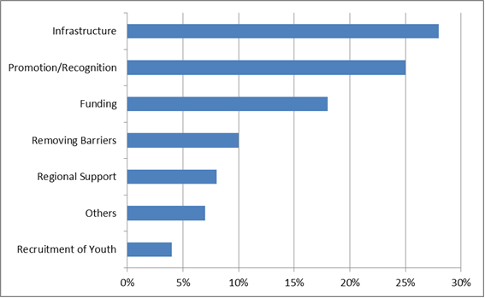

### Highlighted quotes

|  |
| --- |
| Infrastructure:  With funding being obtained through auspices, and they then employ volunteer managers to maintain programs. There is an extreme inconsistency in wages, particularly between rural and metropolitan areas, even though we are running the same programs and achieving the required outcomes - with a huge travel requirement in the rural areas involved. There doesn't seem to be a ‘body’ who regulates this and supports us as ‘volunteer managers’ to be treated equally with our metropolitan counterparts. This may need some consideration in your results and supporting of volunteer managers.  Democracy is a wonderful concept, but it sometimes goes badly wrong when people are put into positions for which they are not suited - which often happens at AGMs. I am aware of the provisions made by CWA to train women in leadership, and think it provides a good model. |

|  |
| --- |
| Promotion/recognition:  Volunteering is not recognised by Government and Business as a legitimate ‘occupation’, especially insofar as ‘retired’ peoples are concerned.  There is the significance, value and importance of volunteering across our communities is widely known, however on the ground this only comes across as a lovely rhetoric with very little action taken to truly support volunteerism  Volunteers are an essential part of our community strength, and this needs to be recognised and promoted to encourage the next generation to become volunteers. |

|  |
| --- |
| Funding:  The volunteers that work at our organisation work with the most vulnerable and disadvantaged in the community, often presenting with extremely complex and sad situations. Paid leadership is essential to ensure that they are well supported in this work. The current budget for the Volunteer Leader is at the expense of other support programs and we strongly encourage State Government to assist with this.  Provide the necessary funding for us to do our jobs properly. Volunteering contributes a significant amount to the economy but the funding is simply not there to support Volunteer Leaders. We are expected to do more with less. |

|  |
| --- |
| Barriers to volunteering:  In an organisation that includes both paid staff and volunteers, there is a large divide between the 2 ‘workers’. The paid staff are the ‘rule makers’ and rarely consider or consult with the Volunteers before putting in place enforceable policy. More times than not, their policies make it more difficult for the volunteer to complete their task, and the paid staff don't care.  One of the biggest inhibitions for prospective volunteers (and the organisations that intend working for) is the liability attached to doing good things on behalf of others. The single most reason I am given by people refusing to volunteer is that even the least onerous duty comes with disproportionate liabilities equivalent to those of senior managers in BHP. We are now all responsible for everyone else - and we carry the liability no matter how stupid the actions of others are. The Nanny State and political correctness have pretty much killed the country - along with all normal sources for volunteers.  The next most inhibiting factor is the requirements of incorporation. Unless the organisation is incorporated, volunteers cannot be covered with personal insurance and office-bearers are personally liable in the event of any catastrophe. Limited liability and insurance are key incentives for volunteers, but the requirements of incorporation are increasingly designed to equate committee members with the Board of BHP - highly onerous requirements that aren't even appropriate for small businesses. It is urgently required to find new means of incorporating very small low-risk organisations so volunteers do not suffer the ridiculous burdens they now face in order to obtain even a low level of protection. |